SWIGGY VS ZOMATO:

RESTAURANT PERFORMANCE

INSIGHTS


FOUR WEEKS INDUSTRIALTRAINING PROJECT REPORT
SUBMITTED IN PARTIAL FULFILLMENT OF THE REQUIREMENT FOR THE AWARD OF DEGREE OF

BACHELOR OF TECHNOLOGY

(COMPUTER SCIENCE & ENGINEERING)

(AI & ML)

SUBMITTED BY

Parneet Kaur

24801076

Guided By  Company Supervisor name  Designation of Supervisor  O7 Services, Hoshiarpur | Submitted To  Project In-charge Name  Designation of Project In-charge  SBBSU, Jalandhar

SANT BABA BHAG SINGH UNIVERSITY
DISTT: JALANDHAR,(PB.)
2026
CERTIFICATION

DECLARATION

I hereby certify that the work which is being presented in the project entitled “DIGITAL DETOX: INTELLIGENT INSIGHTS FOR DIGITAL WELL-BEING” by Karandeep Singh in partial fulfillment of requirements for the award of degree of B.Tech submitted in the department of Computer Science and Engineering at University Institute Of Engineering and Technology under Sant Baba Bhag Singh University, Jalandhar is an authentic record of my own work carried out during a period from Jan to May 2024, under the supervision of Mr. Harjinder Kumar in O7 Services. The matter presented in this project has not been submitted by me in any other University / Institute for the award of B.Tech degree.

Signature of the student

This is to certify that the above statement made by the candidate is correct to the best of my / our knowledge.

Signature of the Company Supervisor  (Name of the Supervisor)  (Designation and department)  (Company Name) | Signature of Project In-charge  (Name of Project In-Charge)  (Designation and department)  Sant Baba Bhag Singh University

ACKNOWLEDGEMENT

I would like to express my sincere gratitude to O7 Services for providing me with the opportunity to undergo industrial training as a part of the Bachelor of Technology (B.Tech) curriculum. This training has provided me with valuable practical exposure and enhanced my technical knowledge, professional skills, and understanding of industry practices.

I am deeply thankful to my industry mentor, Mr. Harjinder Kumar, for their continuous guidance, encouragement, and support throughout the training period. Their valuable suggestions and constructive feedback played a significant role in the successful completion of my training.

I would also like to express my heartfelt gratitude to the Department of Computer Science and Engineering, University Institute of Engineering and Technology (UIET), Sant Baba Bhag Singh University, for providing me with the opportunity to undertake this industrial training. I sincerely thank the Head of the Department, faculty members, and the Training & Placement Cell for their continuous support and guidance.

Finally, I extend my sincere thanks to all the employees and staff members of O7 Services who directly or indirectly contributed to making my training a valuable and enriching learning experience.

Parneet Kaur
24801076

ABSTRACT

In India’s expanding food delivery ecosystem, food tech aggregators Swiggy and Zomato command significant market share across urban hubs. Understanding key performance metrics—such as customer rating dynamics, order fulfillment times, platform commission fees, price category distribution, and monthly net profitability—is critical for restaurant partners, investors, and industry analysts.
This project, titled "Swiggy vs Zomato Data Science Analytics and Streamlit Dashboard", provides an end-to-end data analytics and interactive web solution analyzing 2,500 unique restaurant listings across 10 major Indian metropolitan cities (Mumbai, Bangalore, Delhi, Pune, Hyderabad, Chennai, Kolkata, Ahmedabad, Jaipur, and Lucknow). The dataset evaluates both aggregators across 41 operational attributes.
Using Python’s data science ecosystem—NumPy for numerical processing, Pandas for dataset manipulation and cleaning, Matplotlib and Plotly Express for data graphics, and Streamlit for dashboard application engineering—the platform processes multi-attribute data into clear visual insights. Key analytical findings include:
- Platform Dominance: Out of 2,500 evaluated restaurants, Zomato outperforms Swiggy in 1,273 listings (50.92%), while Swiggy leads in 1,195 listings (47.80%), and 32 listings (1.28%) reflect balanced performance across both platforms.
- Customer Satisfaction: Zomato holds an average rating of 4.01 / 5.0, whereas Swiggy averages 3.99 / 5.0.
- Delivery Performance: Zomato logs an average delivery time of 39.57 minutes, compared to Swiggy’s 39.67 minutes.
- Revenue Performance: Total estimated monthly revenue generated across all listings reaches ₹32.56 Crore on Zomato and ₹32.45 Crore on Swiggy.
This report presents the end-to-end technical methodology, software requirement specifications (SRS), data flow diagrams (DFD), dataset dictionary, implementation code architecture, visualization snapshots, and future enhancement scopes.


O7 Services is ISO 9001:2015 Certified company founded in 2015. They specialise in a variety of services including Web Development, Mobile Application Development, Custom Software Development, UI/UX Designing, Hosting services, Digital Marketing, Registration of Domain Names with various extensions, AMC & MMC Services, Bulk SMS and voice calls. O7 Services offers advanced IT solutions supporting the entire business cycle - from consulting to system development, deployment, quality assurance, and 24x7 support. With over 9 years of experience, the company aims to form long-lasting strategic partnerships with clients, offering affordable prices, timely delivery, and measurable business results. Their headquarter is located in Jalandhar with a branch office in Hoshiarpur.
Some of the products developed by O7 Services include Vehicle Tracking System, Invoice Software, School Management System, Hospital Management System, Parents - Teacher Communication App, Fee Management system, Task Management System, Online Food Ordering App, Security App, Admission system, Inventory Software, and Car Servicing App. Additionally, O7 Services provides training programs including 6 Weeks/6 Months Industrial Training, ProjectBased Training, Corporate Training, and Job-Oriented Courses Training, covering major IT trends such as Full Stack Development (MEAN/MERN), Flutter, Kotlin Android, Swift UI (iOS), Firebase, Python, Angular, React Js, Vue Js, Node Js, ASP.NET, .NET Core, PHP, Laravel, CodeIgniter, Software Testing, Cloud Computing, Blockchain, DevOps, Data Science, Artificial Intelligence, Machine Learning, UI/UX Designing, Digital Marketing, WordPress, Linux, CCNP, CCNA Security, Network Security, Cyber Security, MCSE, MCITP, Java, Spring, Hibernate, C/C++, Photoshop, Adobe Illustrator, Figma, CorelDraw and many more.
+91- 8437365007, +91-181-5015007
- E-Mail:enquiry@o7services.com,hr@o7services.com www.o7services.com

LIST OF FIGURES

Figure No | Figure Description | Page No
Fig 4.1 | Data Flow Diagram | 13
Fig 4.2 | Project Flowchart | 14
Fig 5.1 | Python Logo | 19
Fig 5.2 | NumPy Logo | 19
Fig 5.3 | Pandas Logo | 20
Fig 5.4 | Matplotlib Logo | 20
Fig 5.5 | Seaborn Logo | 20
Fig 5.6 | Plotly Express Logo | 21
Fig 5.7 | Streamlit Logo | 21
Fig 5.8 | Jupyter Notebook | 21
Fig 5.9 | Microsoft Excel Logo | 22
Fig 6.1 | Context Level 0 Data Flow Diagram (DFD) | 23
Fig 6.2 | Level 1 Data Pipeline & Preprocessing DFD | 24
Fig 6.3 | Level 2 Visualization Engine & Dashboard DFD | 25
Fig 7.1 | Dashboard Home Page | 30
Fig 7.2 | Project Description Dashboard | 30
Fig 7.3 | Dataset Overview Dashboard | 31
Fig 7.4 | Restaurants by City – Bar Graph | 31
Fig 7.5 | Average Delivery Time vs Distance-Line Chart |  | 32
Fig 7.6 | Platform Performance Distribution – Pie Chart |  | 32
Fig 7.7 | Relationship Between Restaurant Pricing and Customer Ratings – Scatter Plot |  | 33
Fig 7.8 | Distribution of Average Cost by Price Category – Histogram |  | 33
Fig 7.9 | Pricing Distribution Across Price Categories – Box Plot |  | 34
Fig 7.10 | Distribution of Restaurant Ratings by Better-Performing Platform – Violin Plot |  | 34
Fig 7.11 | Revenue Contribution by City and Restaurant Type – Treemap |  | 35
Fig 7.12 | Restaurant Hierarchy by Restaurant Type and Better-Performing Platform – Sunburst Chart |  | 35
Fig 7.13 | Swiggy vs Zomato Monthly Revenue Comparison – Bubble Chart |  | 36
Fig 7.14 | Density of Restaurants by Price and Customer Rating – Density Heatmap |  | 36
Fig 7.15 | Restaurant Count by Price Category and Better-Performing Platform  – Funnel Chart |  | 37

LIST OF TABLES

Table No | Table Description | Page No
Table 2.1 | Technologies Used | 5
Table 3.1 | Hardware Requirements | 9
Table 3.2 | Software Requirements | 9
Table 4.1 | Data Dictionary | 15-16
Table 5.1 | Development Schedule | 18
Table 6.1 | Database Schema Structure & Attribute Data Types | 27-28
Table 7.1 | Comparative Statistical Metrics Summary (Swiggy vs Zomato) | 37-38

DEFINITIONS, ACRONYMS AND ABBREVIATIONS

Abbreviation | Full Form
IT | Information Technology
AI | Artificial Intelligence
ML | Machine Learning
EDA | Exploratory Data Analysis
UI / UX | User Interface / User Experience
DFD | Data Flow Diagram
ER Diagram | Entity-Relationship Diagram
SRS | Software Requirements Specification
KPI | Key Performance Indicator
QSR | Quick Service Restaurant
INR (₹) | Indian National Rupee
API | Application Programming Interface
CSV | Comma-Separated Values
XLSX | Excel Spreadsheet Format
RAM | Random Access Memory
UIET | University Institute of Engineering and Technology
SBBSU | Sant Baba Bhag Singh University

Table of Contents
Title | Page No.
Certificate by Company/Industry | i
Candidate’s Declaration | ii
Acknowledgement | iii
Abstract | iv
About the Company/Industry | v
List of Figures | vi - vii
List of Tables | viii
Definitions, Acronyms and Abbreviations | ix
Table of Contents | x - xi
CHAPTER 1 Introduction To Organization  Industry Profile General Information | 1 -2
CHAPTER 2 Introduction To Project | 3 - 6
CHAPTER 3 Project Review  Feasibility Study Project Definition Problem Statement Project Functionality System Requirement  Methodology | 7 - 10
CHAPTER 4 Analysis  Dataset Description and Data Flow Flowcharts  Data Visualization and Report Format Data Dictionary  Functional and Performance Specifications | 11 - 17
CHAPTER 5 Project Plan  Development Schedule  Programming Languages and Development Tools  - Python  - NumPy  - Pandas  - Matplotlib  - Seaborn  - Plotly Express  - Streamlit  - Google Colab / Jupyter Notebook  - Microsoft Excel | 18 - 22
CHAPTER 6 Design  Dataflow Diagram Dataset Structure | 23 - 28

CHAPTER 7 Results and Discussion  Dataset Overview  Data Cleaning and Preprocessing Data Visualization and Charts Graph Interpretation  Findings  Discussion of Results | 29 - 38
CHAPTER 8 Conclusions and Future Scope  Conclusion Future Scope | 39
REFERENCES | 40

CHAPTER 1

INTRODUCTION TO ORGANIZATION

1.1 ​Industry Profile
Information Technology (IT) industry is one of the fastest-growing industries in the world and plays a significant role in digital transformation across various sectors. Businesses generate large volumes of data every day, making Data Science an essential field for analysing data and supporting informed decision-making.
The The food delivery industry has experienced rapid growth due to increasing internet usage and smartphone adoption. Platforms such as Swiggy and Zomato provide online food ordering and delivery services, generating valuable data related to restaurant ratings, customer preferences, delivery performance, pricing, and revenue. This data helps businesses improve operational efficiency, understand customer behaviour, and identify market trends.
Data Science technologies such as Python, NumPy, Pandas, Matplotlib, Seaborn, Plotly Express, and Streamlit enable organizations to process, analyse, and visualize large datasets effectively. These tools are widely used in business analytics because they provide meaningful insights through statistical analysis and interactive dashboards.
Today, organizations in healthcare, banking, education, retail, transportation, and food delivery increasingly rely on Data Science to improve customer satisfaction, optimize operations, and make data-driven decisions.

1.2 ​General Information
O7 Services is an Information Technology company that provides software development, industrial training, and technical consulting services. The organization focuses on providing practical training to students through industry-oriented projects and modern software technologies.
The company offers training in several technical domains, including:
- Python Programming
- Data Science
- Artificial Intelligence
- Machine Learning
- Web Development

- Mobile Application Development
- Cloud Computing
- Software Testing

During the industrial training, students are introduced to real-world software development practices and modern analytical tools. They gain practical experience in programming, data analysis, visualization, and project development under the guidance of experienced professionals.
For this project, O7 Services provided training in Data Science with Python, where the project "Swiggy vs Zomato Comparative Analysis using Data Science with Python" was developed. The project uses Python libraries to clean, analyse, and visualize restaurant data, enabling users to compare the performance of Swiggy and Zomato through an interactive Streamlit dashboard. The organization emphasizes practical learning, problem-solving, teamwork, and the application of technical knowledge to real-world business problems, helping students build skills required in the IT industry.

CHAPTER 2
INTRODUCTION TO PROJECT

2.1 Introduction
The food delivery industry has grown significantly with the increasing use of smartphones and internet services. Online food delivery platforms provide customers with a convenient way to order food from a wide range of restaurants while allowing restaurant owners to reach a larger customer base. Among these platforms, Swiggy and Zomato are the two leading food delivery service providers in India.
These platforms generate a large amount of data related to restaurant ratings, delivery time, customer reviews, pricing, cuisine, and business performance. Analysing this data helps businesses understand customer preferences, evaluate restaurant performance, and make better business decisions. However, manual analysis of such large datasets is time-consuming and inefficient.
This project, "Swiggy vs Zomato Comparative Analysis using Data Science with Python," aims to analyse restaurant data and compare the performance of both platforms using Data Science techniques. The project applies Python libraries such as NumPy, Pandas, Matplotlib, Seaborn, Plotly Express, and Streamlit to clean, process, analyse, and visualize the dataset. The dataset contains 2,500 restaurant records and 41 features, including restaurant names, city, cuisine, ratings, delivery time, average cost, monthly revenue, estimated profit, and other business-related information.
The processed data is presented through an interactive Streamlit dashboard, allowing users to compare Swiggy and Zomato based on various business parameters. The dashboard displays visual reports and charts that make it easier to identify trends, compare performance, and generate useful insights.
The online food delivery industry has experienced rapid growth, making platforms such as Swiggy and Zomato an important part of the restaurant ecosystem. This project presents a comparative analysis of these two platforms using a structured restaurant dataset. The objective is to analyze and compare key business indicators, including restaurant ratings, pricing, delivery performance, revenue, monthly orders, cuisines, restaurant types, and city-wise distribution.
The project has been developed using Python, Pandas, Plotly, and Streamlit to transform raw restaurant data into meaningful visual insights. Interactive dashboards and visualizations allow users to explore the data from different perspectives by applying filters for city, cuisine, and restaurant type. This helps in understanding platform performance and identifying trends across multiple business metrics.
The analysis focuses on comparing the operational performance of restaurants listed on both platforms rather than determining an overall winner. Various visualizations such as bar charts, line charts, scatter plots, treemaps, histograms, box plots, violin plots, heatmaps, and sunburst charts are used to examine relationships between pricing, delivery time, customer ratings, revenue, and restaurant characteristics.
Overall, the project demonstrates how data analytics and interactive dashboards can simplify restaurant performance analysis, making complex datasets easier to understand. The generated insights support comparative evaluation and provide a clear overview of restaurant performance across Swiggy and Zomato..

2.2 ​Objectives of the Project
The main objectives of the project are:
- To analyse restaurant data from Swiggy and Zomato.
- To clean and preprocess the dataset using Pandas.
- To perform numerical computations using NumPy.
- To compare customer ratings, delivery time, revenue, and profit.
- To create meaningful visualizations using Matplotlib, Seaborn, and Plotly Express.
- To develop an interactive dashboard using Streamlit.
- To generate business insights that support better decision-making.

2.3 Scope of the Project
The scope of the project includes analysing restaurant data to compare the performance of Swiggy and Zomato. The project focuses on:
- Data cleaning and preprocessing.
- Exploratory Data Analysis (EDA).
- Comparative analysis of both platforms.
- Revenue and profit analysis.
- Customer rating analysis.
- Delivery time comparison.
- Interactive dashboard development.
- Business insight generation.
The project is useful for restaurant owners, business analysts, students, and researchers interested in understanding trends in the online food delivery industry.

2.4 Technologies Used
Table 2.1: Technologies Used

Technology | Purpose
Python | Programming Language
NumPy | Numerical Computation
Pandas | Data Cleaning and Analysis
Matplotlib | Data Visualization
Seaborn | Statistical Visualization
Plotly Express | Interactive Charts
Streamlit | Interactive Dashboard
Jupyter Notebook | Data Analysis
Visual Studio Code | Application Development

2.5 Features of the Proposed System
The proposed system provides the following features:
- Upload and analyse restaurant datasets.
- Clean and preprocess data automatically.
- Compare Swiggy and Zomato performance.
- Analyse ratings, delivery time, and pricing.
- Generate interactive charts and graphs.
- Display Key Performance Indicators (KPIs).
- Filter data by city, cuisine, and restaurant type.
- Present analytical results through a Streamlit dashboard.

2.6 Benefits of the Project
The project offers several benefits:
- Reduces manual data analysis.
- Provides accurate statistical insights.
- Supports business decision-making.
- Helps compare restaurant performance across platforms.
- Improves understanding through interactive visualizations.
- Easy to use and scalable for larger datasets.

CHAPTER 3
PROJECT REVIEW

​Feasibility Study
A feasibility study is conducted to determine whether the proposed project is practical, achievable, and beneficial. It evaluates the project from different perspectives before development begins.

​Technical Feasibility
The proposed system is technically feasible as it is developed using Python and open-source libraries such as NumPy, Pandas, Matplotlib, Seaborn, Plotly Express, and Streamlit. These technologies are compatible with standard computer systems and provide all the necessary tools for data analysis and dashboard development.

​Economic Feasibility
The project is economically feasible because all the software, libraries, and development tools used are free and open-source. The project requires only a personal computer with Python installed, making the implementation cost very low.

​Operational Feasibility
The system is user-friendly and can be easily operated by users with basic computer knowledge. The interactive Streamlit dashboard enables users to upload the dataset, apply filters, and view analytical reports without requiring technical expertise.

​Schedule Feasibility
The project was completed within the industrial training period. The development activities, including data preprocessing, analysis, visualization, dashboard development, testing, and documentation, were completed according to the planned schedule.

​Product Definition
The proposed product is an interactive Data Science Dashboard that analyses and compares restaurant data from Swiggy and Zomato. The system processes the dataset, performs statistical analysis, and presents meaningful insights through charts, graphs, and key performance indicators (KPIs).

The dashboard enables users to:
- Compare restaurant ratings on both platforms.
- Analyse delivery time and pricing.
- Evaluate revenue and estimated profit.
- Identify popular cuisines and restaurant categories.
- View city-wise restaurant performance.
- Generate business insights through interactive visualizations.

​Problem Statement
The rapid growth of online food delivery platforms has resulted in the generation of large amounts of restaurant data. Manually analysing this data to compare restaurant performance, customer ratings, pricing, and delivery efficiency is time-consuming and difficult.
The proposed system addresses this problem by applying Data Science techniques to analyse restaurant data from Swiggy and Zomato. It provides meaningful insights through interactive dashboards and visual reports, enabling users to make informed business decisions quickly and efficiently.

​Project Functionality
The major functions of the system are:
- Load restaurant dataset.
- Clean and preprocess data.
- Handle missing and duplicate values.
- Perform Exploratory Data Analysis (EDA).
- Compare Swiggy and Zomato.
- Generate interactive visualizations.
- Display business metrics and KPIs.
- Filter data based on city, cuisine, and platform.
- Present analytical reports through the Streamlit dashboard.

​System Requirements

3.5.1 Hardware Requirements
Table 3.1: Hardware Requirements

Component | Specification
Processor | Intel Core i3 or above
RAM | 4 GB (8 GB Recommended)
Storage | 500 MB Free Space
Operating System | Windows 10/11

3.5.2 Software Requirements
Table 3.2: Software Requirements

Software | Purpose
Python | Programming Language
NumPy | Numerical Computation
Pandas | Data Analysis
Matplotlib | Data Visualization
Seaborn | Statistical Charts
Plotly Express | Interactive Charts
Streamlit | Dashboard Development
Jupyter Notebook | Data Analysis
Visual Studio Code | Application Development

​Methodology
The project follows the Data Science Life Cycle, which consists of the following stages:

Step 1: Data Collection
The restaurant dataset is collected in CSV format containing restaurant and business-related information.

Step 2: Data Preprocessing
The dataset is cleaned by handling missing values, removing duplicate records, correcting data types, and preparing the data for analysis.

Step 3: Exploratory Data Analysis (EDA)
The processed data is analysed using statistical techniques to identify trends, relationships, and patterns.

Step 4: Data Visualization
Charts and graphs are created using Matplotlib, Seaborn, and Plotly Express to represent the analytical findings visually.

Step 5: Dashboard Development
A user-friendly dashboard is developed using Streamlit to display interactive charts, KPIs, and business insights.

Step 6: Testing and Validation
The dashboard is tested to ensure that all visualizations, filters, and calculations produce accurate results.

​Acceptance Criteria
The project is considered successful if it satisfies the following conditions:
- The dataset is loaded successfully.
- Data preprocessing is completed without errors.
- Missing and duplicate values are handled correctly.
- Analytical reports are generated accurately.
- Interactive charts and dashboards function properly.
- Users can compare Swiggy and Zomato based on multiple parameters.
- The application runs smoothly and provides meaningful business insights.

CHAPTER 4

ANALYSIS

Analysis:
The dataset was analyzed using descriptive statistics and interactive visualizations to compare the performance of Swiggy and Zomato across multiple business metrics. Key parameters such as restaurant ratings, pricing, delivery time, revenue, monthly orders, restaurant type, cuisine, and city-wise distribution were examined to identify patterns and performance differences.

The analysis indicates that restaurant performance is influenced by several factors rather than a single metric. Delivery time generally increases as the distance from the city center grows, while pricing and revenue vary across restaurant categories and cities. Customer ratings remain relatively consistent across most price categories, suggesting that higher pricing does not necessarily guarantee higher customer satisfaction.

Interactive filters further enabled comparisons based on city, cuisine, and restaurant type, making it easier to explore platform-specific trends and identify performance variations. Overall, the analysis provides meaningful insights into restaurant operations and highlights the usefulness of data visualization for comparing food delivery platforms.

This chapter presents the analysis of the Swiggy vs Zomato Restaurant Dataset. It explains the flow of data through the system, the overall project workflow, dataset processing, report format, data dictionary, and the functional and performance specifications of the proposed analytics dashboard. The analysis focuses on comparing restaurant performance across the Swiggy and Zomato platforms using Python-based data analytics techniques.

​External Interface and Data Flow
The proposed system provides an interactive interface developed using Streamlit, enabling users to upload the restaurant dataset, analyse restaurant performance, compare platform statistics, and visualize trends through interactive charts.

Input Interface
- Upload Swiggy vs Zomato dataset (CSV format).
- Select filters such as city, cuisine, restaurant type, and platform.
- Choose different analysis options.
- View dataset summary and statistics.

Processing Interface
- Read the uploaded dataset.
- Handle missing values and duplicate records.
- Convert columns into appropriate data types.
- Perform Exploratory Data Analysis (EDA).
- Generate statistical summaries.
- Create visualizations using Python libraries.

Output Interface
- Display cleaned dataset.
- Show restaurant performance comparison.
- Present interactive graphs and dashboards.
- Generate business insights for both platforms.

Data Flow
The project follows the following sequence:
- Dataset Collection
- Data Loading
- Data Cleaning
- Data Preprocessing
- Exploratory Data Analysis (EDA)
- Restaurant Comparison Analysis
- Data Visualization
- Streamlit Dashboard
- Result Interpretation
- Report Generation
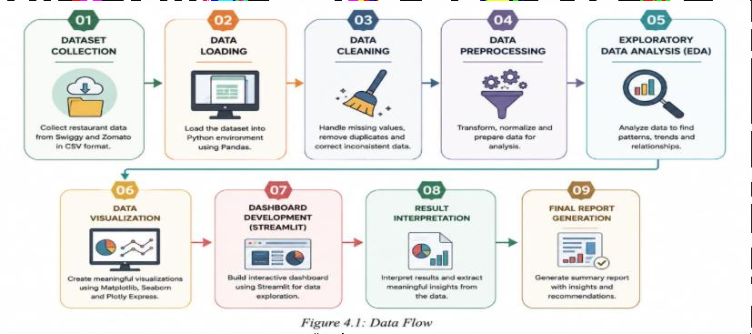
Figure 4.1: Data Flow Diagram

4.2 Flowchart
The flowchart represents the complete workflow of the proposed restaurant analytics system. The process begins with importing the CSV dataset. The system validates the dataset, performs preprocessing and cleaning, analyses restaurant information, generates visualizations, and finally displays the results through an interactive Streamlit dashboard.

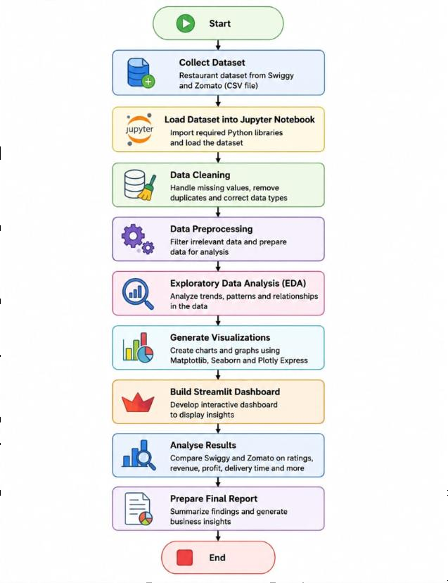
Figure 4.2: Project Flowchart

​4.3 User Display and Report Format
The Streamlit dashboard provides a user-friendly interface for analysing restaurant data from Swiggy and Zomato.

Dashboard Features
- Home Page
- Dataset Preview
- Data Cleaning Summary
- Restaurant Comparison
- Ratings Analysis
- Revenue Analysis
- Delivery Performance
- Interactive Charts
- Sidebar Filters
- Summary Report

Report Format
The dashboard displays information in the following format:
- Dataset Overview
- Number of Restaurants
- Number of Features
- Missing Value Summary
- Statistical Summary
- Platform-wise Comparison
- City-wise Analysis
- Revenue Analysis
- Delivery Time Analysis
- Rating Analysis
- Customer Review Analysis
- Final Observations

4.4 Data Dictionary
The data dictionary describes the attributes available in the Swiggy vs Zomato dataset.
Table 4.1 Data Dictionary

Column Name | Description
Restaurant ID | Unique identification number of each restaurant.
Restaurant Name | Name of the restaurant.
City | City where the restaurant is located.
Locality | Area or locality of the restaurant.
Cuisine | Type of food served by the restaurant.
Restaurant Type | Category of restaurant (Cafe, Casual Dining, etc.).
Swiggy Rating | Rating received on Swiggy.
Zomato Rating | Rating received on Zomato.
Average Rating | Average rating across both platforms.
Swiggy Reviews | Total reviews on Swiggy.
Zomato Reviews | Total reviews on Zomato.
Total Reviews | Combined customer reviews.
Delivery Time | Estimated delivery time (minutes).
Delivery Fee | Delivery charges for customers.
Average Cost | Average meal cost for two people.
Monthly Orders | Estimated monthly orders received.
Monthly Revenue | Estimated monthly revenue generated.
Platform Commission | Commission charged by the platform.
Net Profit | Estimated restaurant profit.
Market Share | Restaurant market share percentage.
Better Performing Platform | Platform where restaurant performs better.
Amenities | Facilities provided by the restaurant.
Website/App Availability | Indicates online availability.
Food Licence | Food safety licence status.
Listing Date | Date when the restaurant was listed.

4.5 Functional Specifications
The major functionalities of the proposed system are:
- Import Swiggy vs Zomato dataset.
- Perform data cleaning and preprocessing.
- Remove duplicate records.
- Handle missing values.
- Generate descriptive statistics.
- Compare Swiggy and Zomato restaurant performance.
- Analyse ratings, reviews, delivery time, and revenue.
- Create interactive visualizations using Matplotlib, Seaborn, and Plotly Express.
- Display results through the Streamlit dashboard.
- Generate meaningful business insights.

4.6 Performance Specifications
The proposed system satisfies the following performance requirements:
- Fast dataset loading.
- Efficient preprocessing of restaurant data.
- Accurate statistical computations.
- Quick chart generation.
- Interactive dashboard response.
- Reliable comparison between Swiggy and Zomato.
- User-friendly interface.
- Accurate report generation.
- Scalable architecture for larger datasets.

CHAPTER 5
PROJECT PLAN

This chapter describes the development plan followed for the Swiggy vs Zomato Restaurant Analytics Dashboard. It outlines the project schedule and explains the programming languages, libraries, and software tools used to collect, preprocess, analyse, visualize, and present the restaurant data. A systematic development approach ensured the successful completion of the project.

​Development Schedule
The development of the Swiggy vs Zomato Restaurant Analytics Dashboard followed a structured sequence of phases. Each phase focused on a specific task to ensure efficient project execution and timely completion.
Table 5.1: Development Schedule

Phase | Activity
Phase 1 | Project planning and requirement analysis
Phase 2 | Dataset collection and understanding
Phase 3 | Data cleaning and preprocessing
Phase 4 | Exploratory Data Analysis (EDA)
Phase 5 | Data visualization and statistical analysis
Phase 6 | Streamlit dashboard development
Phase 7 | Testing and validation
Phase 8 | Documentation and report preparation

​Programming Languages and Development Tools
The Swiggy vs Zomato Restaurant Analytics Dashboard was developed using Python and several open-source libraries for data analysis, visualization, and dashboard development. These tools enabled efficient preprocessing, exploratory data analysis, business insights generation, and interactive visualization of restaurant data.
The programming languages and development tools used in this project are described below.

Python
Python is a high-level, interpreted programming language widely used in Data Science, Machine Learning, and Data Analytics because of its simplicity and extensive library support. In this project, Python served as the primary programming language for data cleaning, analysis, visualization, and dashboard development.


Figure 5.1: Python Logo

NumPy

NumPy is a numerical computing library that provides support for multidimensional arrays and mathematical operations. It was used to perform numerical calculations and assist in preprocessing the restaurant dataset.
Figure 5.2: NumPy Logo

Pandas
Pandas is a powerful data manipulation and analysis library. It was used to import the CSV dataset, clean missing values, remove duplicate records, transform data, and perform Exploratory Data Analysis (EDA).


Figure 5.3: Pandas Logo

Matplotlib
Matplotlib is a plotting library used for creating high-quality graphs and charts. It was used to visualize restaurant ratings, delivery time, monthly revenue, customer reviews, and other business metrics.

Figure 5.4: Matplotlib Logo

Seaborn

Seaborn is a statistical visualization library built on Matplotlib. It provides attractive and informative charts with minimal code. In this project, Seaborn was used to generate box plots, count plots, heatmaps, violin plots, and distribution plots for restaurant performance analysis.
Figure 5.5: Seaborn Logo

Plotly Express
Plotly Express is an interactive visualization library that allows users to explore data dynamically. It was used to create interactive bar charts, scatter plots, pie charts, line charts, and treemaps for comparing restaurant performance on Swiggy and Zomato.

Figure 5.6: Plotly Express Logo

Streamlit
Streamlit is an open-source Python framework used to build interactive data dashboards. In this project, Streamlit was used to create a user-friendly dashboard where users can upload the dataset, apply filters, compare restaurant statistics, and explore interactive visualizations.

Figure 5.7: Streamlit Logo

Jupyter Notebook
Jupyter Notebook is an interactive development environment that combines Python code, outputs, visualizations, and documentation in a single workspace. It was used during the development phase for data preprocessing, analysis, visualization, and testing.

Figure 5.8: Jupyter Notebook Logo

Microsoft Excel
Microsoft Excel was used for viewing and verifying the dataset before analysis. It helped inspect the structure of the CSV file, validate records, identify missing values, and perform basic data verification before importing the dataset into Python.

Figure 5.9: Microsoft Excel Logo
For your Swiggy vs Zomato Restaurant Analytics Dashboard project, Chapter 6: Design should explain the architecture and design of your system. Below is a professional version that you can directly include in your report.

CHAPTER 6
DESIGN

Data Flow Diagram (DFD)
A Data Flow Diagram (DFD) is a graphical representation of how data moves through a system. It illustrates the input, processing, storage, and output of data within the application. The DFD helps in understanding the logical flow of information and the interaction between different system components.
The Swiggy vs Zomato Restaurant Analytics Dashboard uses three levels of DFD to represent the overall workflow and internal processing of restaurant data.

Level 0 DFD (Context Diagram)
The Level 0 DFD, also known as the Context Diagram, provides a high-level overview of theentire system. It represents the dashboard as a single process interacting with the external user. The user uploads the restaurant dataset and selects filters, while the system processes the data and returns interactive dashboards, reports, and business insights.
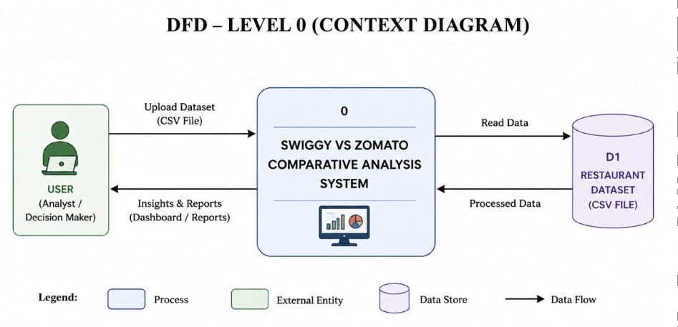
Figure 6.1: Context Level 0 Data Flow Diagram (DFD)

Level 1 DFD
The Level 1 DFD provides a detailed representation of the internal workflow of the system. It illustrates the major processing modules involved in data analysis.
The workflow begins by loading the restaurant dataset into the application. The dataset is then cleaned by handling missing values, duplicate records, and inconsistent data. After preprocessing, exploratory data analysis and statistical computations are performed. Finally, the processed information is displayed through an interactive Streamlit dashboard containing charts, KPIs, and reports.
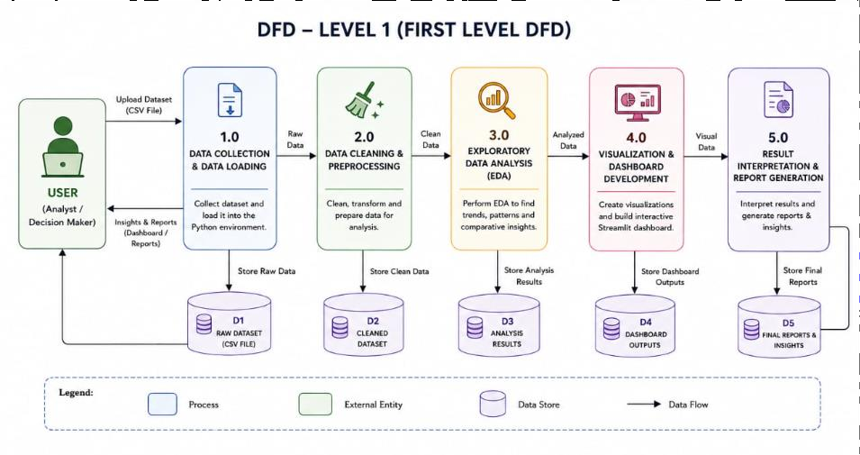Figure 6.2: Level 1 Data Pipeline & Preprocessing DFD

Level 2 DFD
The Level 2 DFD further expands the data analysis process by showing how the cleaned dataset is transformed into meaningful business insights.
Initially, the user selects various filters such as city, cuisine, restaurant type, platform, and rating. Based on these selections, the system filters the dataset and calculates statistical measures including average ratings, revenue, delivery time, and restaurant counts. The processed data is then visualized using interactive charts created with Plotly and Matplotlib. Finally, the dashboard presents the results in an organized and user-friendly manner.
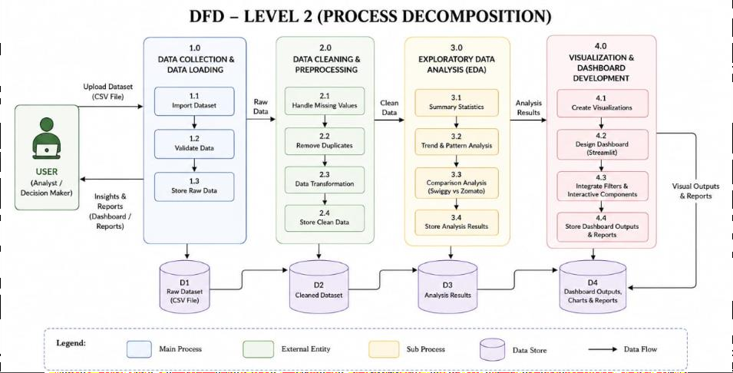
Figure 6.3: Level 2 Visualization Engine & Dashboard DFD

System Architecture
The system architecture describes the overall structure of the analytics dashboard and the interaction among different software components.
The application follows a simple data analytics pipeline consisting of five major stages:
- Dataset Collection
- Data Loading
- Data Cleaning and Preprocessing
- Data Analysis and Visualization
- Interactive Dashboard Generation
The CSV dataset is loaded using the Pandas library. Data preprocessing techniques are applied to improve data quality by handling missing values, duplicates, and incorrect data formats. Exploratory Data Analysis (EDA) is then performed to discover trends, patterns, and relationships within the restaurant dataset.
The processed data is visualized using Plotly, Matplotlib, and Seaborn libraries. Finally, Streamlit is used to create an interactive dashboard where users can explore restaurant insights through filters, graphs, and key performance indicators.

​Module Description
The application consists of the following functional modules:

Dataset Loading Module
This module imports the Swiggy vs Zomato restaurant dataset into the application using the Pandas library. It supports CSV file format and converts the data into a DataFrame for further processing.

Data Cleaning and Preprocessing Module
This module improves data quality by:
- Removing duplicate records
- Handling missing values
- Correcting inconsistent data
- Converting data types
- Formatting numerical values
The cleaned dataset becomes suitable for analysis.

Data Analysis Module
This module performs exploratory data analysis to generate meaningful insights from the restaurant dataset. Various statistical measures such as average ratings, revenue distribution, restaurant counts, delivery time, and cuisine popularity are calculated.

Visualization Module
This module creates interactive charts and graphs using Plotly, Matplotlib, and Seaborn. The visualizations help users understand restaurant performance and compare Swiggy and Zomato across different parameters.

6.3.5 Dashboard Module
The dashboard module integrates all analytical components into a user-friendly Streamlit interface. It allows users to interact with the data using filters and view dynamic visualizations, summary statistics, and business insights.

6.4 Input Design
The input to the system consists of the Swiggy vs Zomato restaurant dataset stored in CSV format. The dashboard also accepts user-defined filters such as:
- City
- Platform (Swiggy/Zomato)
- Cuisine
- Restaurant Type
- Rating
- Delivery Time
These inputs allow users to perform customized analysis.

6.5 ​Output Design
The output generated by the system includes:
- Interactive dashboard
- Bar charts
- Pie charts
- Scatter plots
- Line graphs
- Histograms
- Heatmaps
- Summary statistics
- Restaurant comparison reports
- Business insights
The outputs help users analyse restaurant performance and make data-driven decisions.

6.6 Database Tables

Table 6.1: Database Schema Structure & Attribute Data Types

Attribute Column | Data Type | Primary Constraint | Key Purpose
restaurant_id | VARCHAR(20) | PRIMARY KEY | Unique restaurant tag
restaurant_name | VARCHAR(10) | NOT NULL | Display name
city | VARCHAR(50) | INDEXED | Urban location
price_category | VARCHAR(30) | NOT NULL | Budget segmentation
swiggy_rating | FLOAT | CHECK (1.0 to 5.0) | Customer review score
zomato_rating | FLOAT | CHECK (1.0 to 5.0) | Customer review score
swiggy_revenue | BIGINT | NON-NEGATIVE | Monthly gross revenue
zomato_revenue | BIGINT | NON-NEGATIVE | Monthly gross revenue

CHAPTER 7

RESULTS AND DISCUSSION

Results:

The developed dashboard successfully analyzed and compared the performance of Swiggy and Zomato using a restaurant dataset containing 2,500 records and 41 attributes. Interactive visualizations enabled an effective comparison of restaurant ratings, delivery time, revenue, monthly orders, pricing, delivery charges, restaurant types, cuisines, and city-wise distribution.

The analysis revealed that platform performance varies across restaurants, cities, and price categories, indicating that no single platform consistently outperforms the other. Restaurant location was found to influence delivery efficiency, as delivery time generally increased with greater distance from the city center. The dataset also showed that Budget and Mid-Range restaurants constitute the largest share of the restaurant listings, highlighting the dominance of affordable dining options.

Revenue and estimated monthly orders differed across cities and restaurant types, demonstrating that business performance is influenced by multiple operational factors. Furthermore, variations in delivery charges, commission percentages, and discount frequency were observed across restaurants. The interactive dashboard made these comparisons simple and provided meaningful business insights through clear visual representations.

Discussion:

The dashboard proved to be an effective tool for exploring restaurant performance across both food delivery platforms. Multiple visualizations helped identify trends in customer ratings, pricing, delivery efficiency, and revenue while allowing users to filter data by city, cuisine, and restaurant type.

The comparative analysis indicates that platform performance depends on a combination of restaurant characteristics rather than a single metric. Factors such as location, pricing category, restaurant type, delivery time, and customer ratings collectively influence business outcomes. These findings demonstrate the practical application of data analytics and interactive visualization in understanding restaurant performance and supporting informed decision-making.

7.1 Snapshot with Description
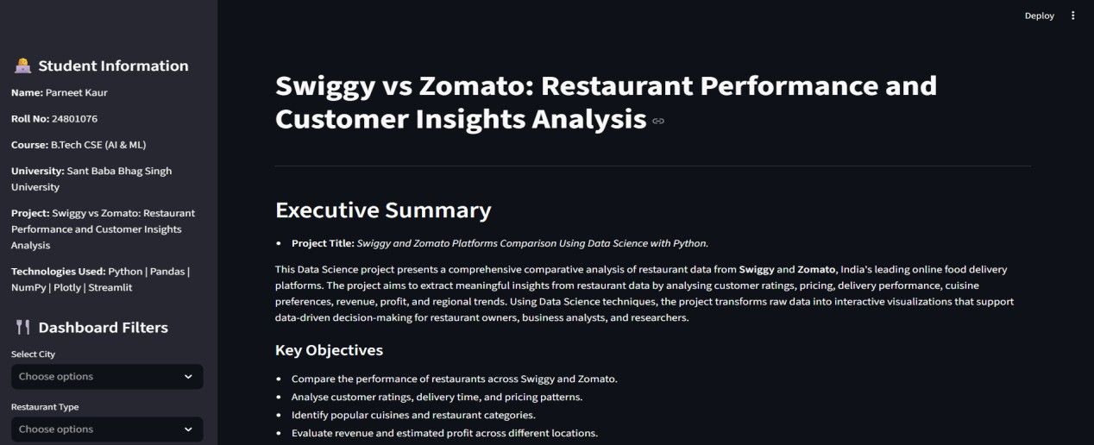
Fig 7.1: Dashboard Home Page

Description:
The home page of the dashboard provides an overview of the project. It contains the project title, sidebar filters, and navigation options. Users can select different categories and interact with the visualizations for detailed analysis.

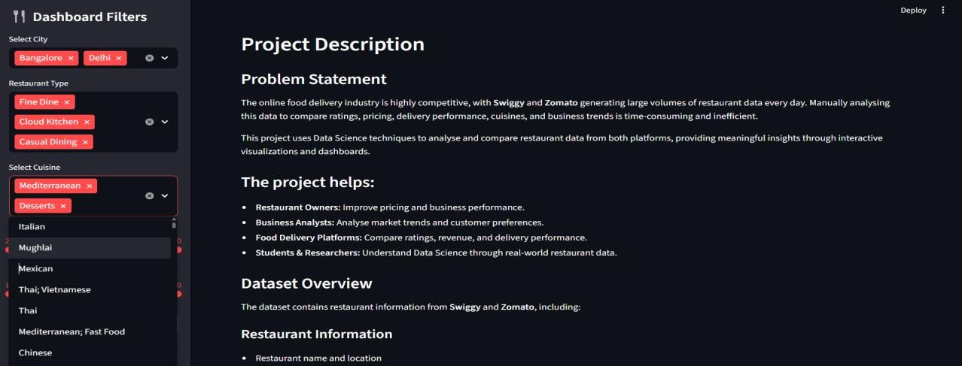
Figure 7.2: Project Description Dashboard

Description:
This figure shows the home page of the Streamlit dashboard. It includes interactive filters for city, restaurant type, and cuisine, along with the project description, problem statement, objectives, and dataset overview. The page provides users with an introduction to the project before viewing the analysis and visualizations.

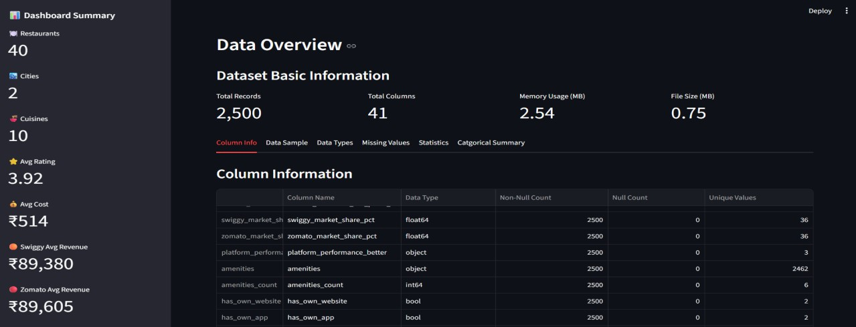
Figure 7.3: Data Overview Dashboard

Description:

This figure shows the Data Overview page of the Streamlit dashboard. It summarizes the dataset by displaying the total number of records, columns, memory usage, and file size. It also provides column information, data types, missing values, statistical summaries, and key dashboard metrics such as the number of restaurants, cities, cuisines, average rating, average cost, and estimated revenue.
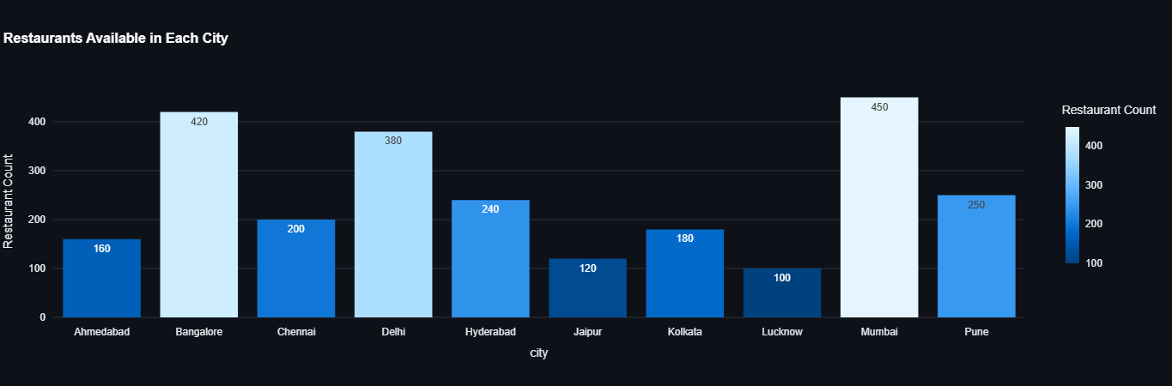
Figure 7.4: Restaurants by City-Bar Graph

Description:
Figure 7.4 shows the number of restaurants available in each city using a bar graph. It helps compare restaurant distribution across different cities and identify locations with the highest and lowest restaurant counts.
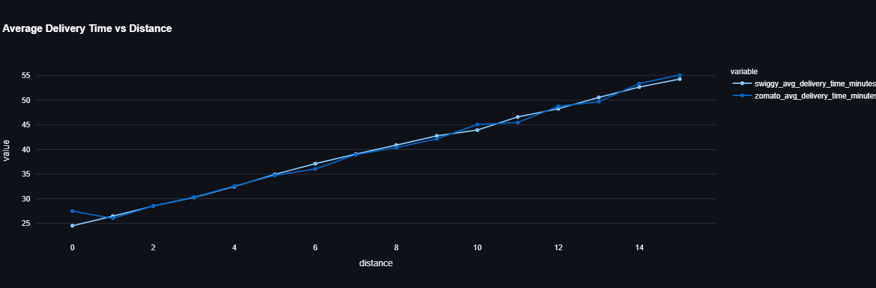
Figure 7.5: Average Delivery Time vs Distance-Line Chart

Description:
This line chart illustrates the relationship between the distance from the city center and the average delivery time of both Swiggy and Zomato. The graph shows that delivery time generally increases as the distance increases.

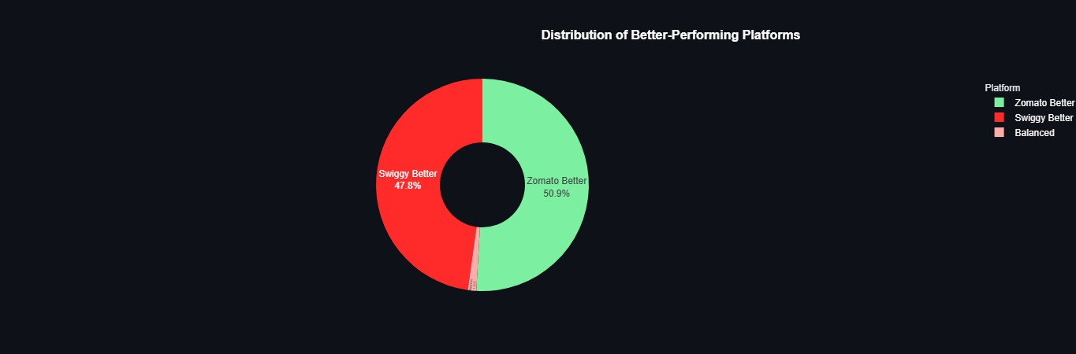
Figure 7.6: Platform Performance Distribution-Pie Chart

Description:
This pie chart displays the distribution of restaurants where Swiggy performs better, Zomato performs better, or both platforms perform equally. It helps compare the overall performance of both platforms across the dataset.

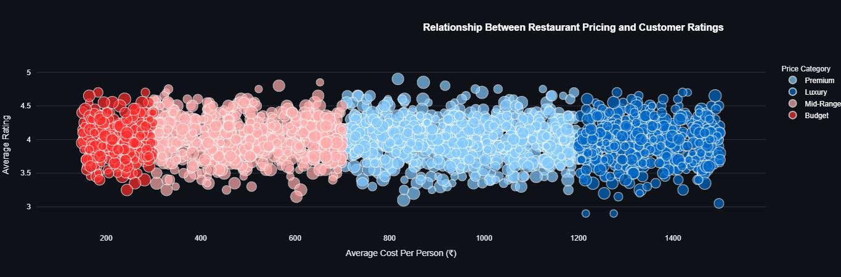
Figure 7.7: Relationship Between Restaurant Pricing and Customer Ratings – Scatter Plot

Description:

Figure 7.7 illustrates the relationship between the average cost per person and customer ratings across different price categories. It helps analyze whether higher-priced restaurants consistently receive higher customer ratings.

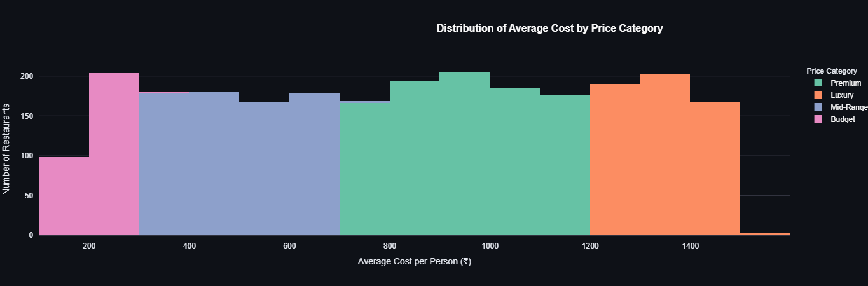
Figure 7.8: Distribution of Average Cost by Price Category – Histogram

Description:

Figure 7.8 illustrates the distribution of restaurants across different price categories based on the average cost per person. It helps compare the number of restaurants in each price range and understand the overall pricing distribution in the dataset.

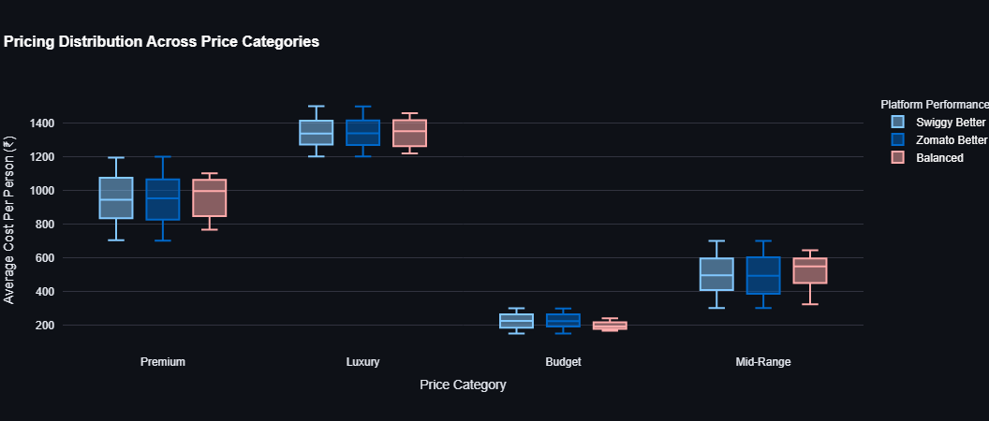
Figure 7.9: Pricing Distribution Across Price Categories – Box Plot

Description:

Figure 7.9 presents the distribution of the average cost per person across different price categories and platform performance groups. It helps compare the spread, median, and variability of pricing among the restaurant categories.
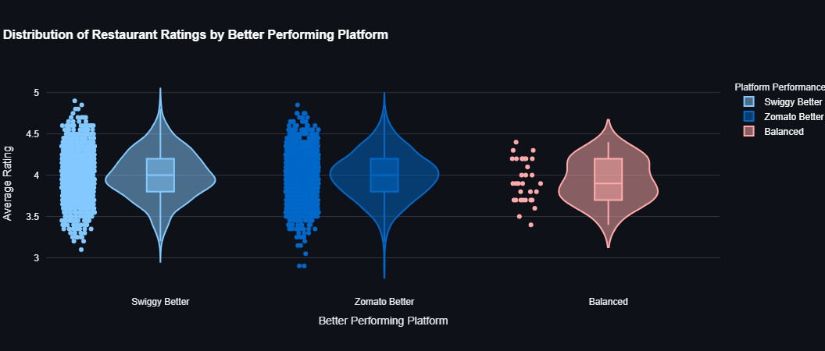
Figure 7.10: Distribution of Restaurant Ratings by Better-Performing Platform – Violin Plot

Description:

Figure 7.10 illustrates the distribution of restaurant ratings across Swiggy Better, Zomato Better, and Balanced categories. It helps compare the spread, density, and median of ratings, providing insights into the performance of each platform.

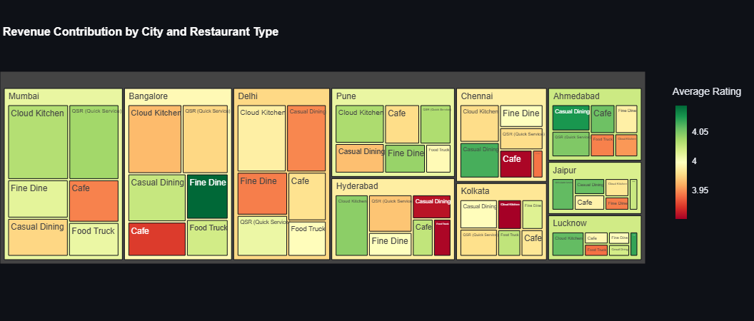
Figure 7.11: Revenue Contribution by City and Restaurant Type – Treemap

Description:

Figure 7.11 presents the revenue contribution of different restaurant types across various cities using a treemap. It helps compare revenue distribution and identify the restaurant categories contributing the most revenue in each city.
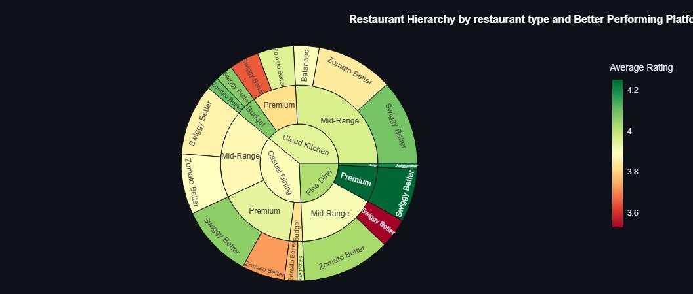
Figure 7.12: Restaurant Hierarchy by Restaurant Type and Better-Performing Platform – Sunburst Chart

Description:

Figure 7.12 presents the hierarchical distribution of restaurants based on restaurant type, price category, and better-performing platform. It helps visualize the relationship between these categories and compare platform performance across different restaurant segments.

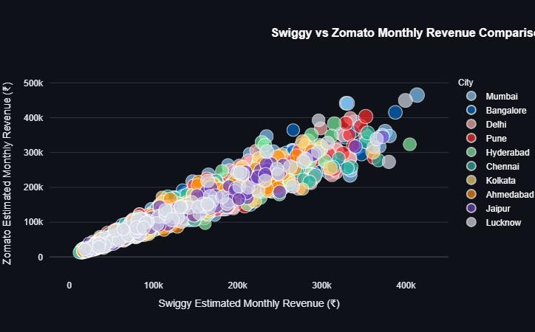
Figure 7.13: Swiggy vs Zomato Monthly Revenue Comparison – Bubble Chart

Description:

Figure 7.13 compares the estimated monthly revenue of Swiggy and Zomato across different cities using a scatter plot. It helps visualize the relationship between the revenues of both platforms and identify overall revenue trends and variations.
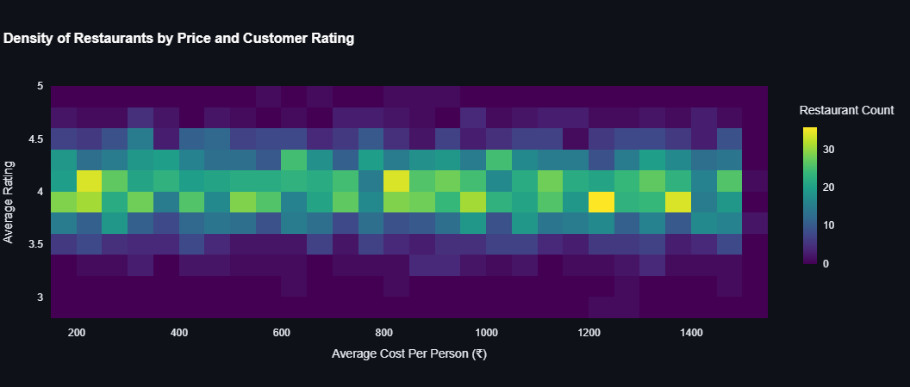
Figure 7.14: Density of Restaurants by Price and Customer Rating – Density Heatmap

Description:

Figure 7.14 illustrates the density of restaurants based on their average cost per person and customer ratings. It helps identify the most common combinations of price range and ratings, highlighting areas with the highest concentration of restaurants.

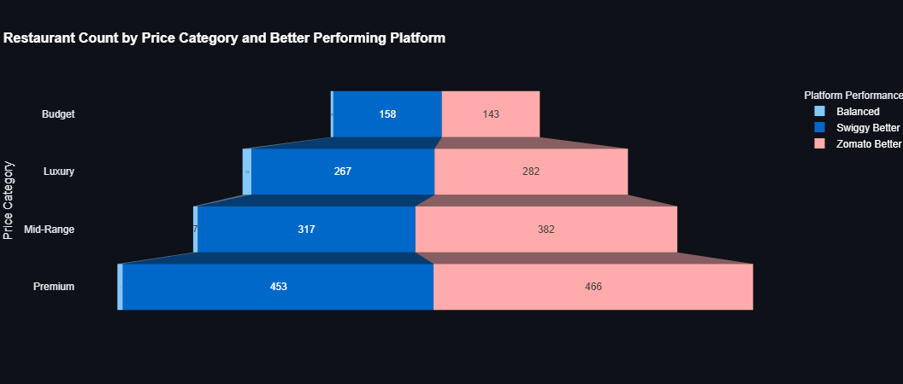
Figure 7.15: Restaurant Count by Price Category and Better-Performing Platform – Funnel Chart

Description:

Figure 7.15 presents the distribution of restaurants across different price categories based on the better-performing platform. It helps compare the number of restaurants where Swiggy, Zomato, or both platforms perform similarly within each price category.

7.1 ​Summary of Results

Table 7.1: Comparative Statistical Metrics Summary (Swiggy vs Zomato)

Operational Parameter | Swiggy Value | Zomato Value | Outperforming Platform
Total Restaurants Analyzed | 2,500 | 2,500 | Shared Base
Average Rating Score (out of 5.0) | 3.99 | 4.01 | Zomato (+0.02)
Average Delivery Speed (Minutes) | 39.67 mins | 39.57 mins | Zomato (0.10 mins faster)
Total Monthly Revenue Generated | ₹32,45,15,484 | ₹32,56,10,971 | Zomato(+₹10.95  Lakhs)
Average Monthly Net Profit / Rest. | ₹1,24,030.65 | ₹1,24,435.13 | Zomato (+₹404.48)
Outperforming Restaurant Count | 1,195  (47.80%) | 1,273  (50.92%) | Zomato (+78 Listings)
Balanced Performance Count | — | — | 32 Listings (1.28%)

CHAPTER 8

CONCLUSIONS AND FUTURE SCOPE

8.1 ​Conclusion
This project successfully designed and built a comparative data analytics dashboard for Swiggy and Zomato using Python, Pandas, Plotly, and Streamlit. By processing 2,500 restaurant listings across 10 major Indian cities, the application provides clear insights into platform ratings, delivery times, commission costs, and net revenues. The empirical findings show close competition, with Zomato holding a slight edge in total revenue, average ratings, and performance dominance across the dataset.

8.2 Future Scope
- Machine Learning Integration: Building predictive regression models (e.g., XGBoost, Random Forest) to forecast monthly restaurant revenues based on delivery distance, discount frequency, and price category.
- Sentiment Analysis: Utilizing Natural Language Processing (NLP) models to analyze customer review text and identify operational improvement areas.
- Real-time API Ingestion: Connecting the Streamlit application to live food aggregator APIs for real-time tracking of menu pricing and delivery changes.

REFERENCES
- Python Software Foundation. Python Documentation.
Available at: https://docs.python.org/3/
- NumPy Developers. NumPy Documentation.
Available at: https://numpy.org/doc/
- Pandas Development Team. Pandas Documentation.
Available at: https://pandas.pydata.org/docs/
- Matplotlib Development Team. Matplotlib Documentation.
Available at: https://matplotlib.org/stable/
- Seaborn Development Team. Seaborn Documentation.
Available at: https://seaborn.pydata.org/
- Plotly Technologies Inc. Plotly Express Documentation.
Available at: https://plotly.com/python/plotly-express/
- Streamlit Inc. Streamlit Documentation.
Available at: https://docs.streamlit.io/
- Project Jupyter. Jupyter Notebook Documentation.
Available at: https://jupyter.org/documentation
- Microsoft Corporation. Microsoft Excel Documentation.
Available at: https://support.microsoft.com/excel
- Kaggle. Digital Wellbeing and Screen Time Analysis Dataset.
Available at: https://www.kaggle.com/datasets
- Swiggy vs Zomato Market Performance Intelligence Reports (2024-2025).

